***Original article***

**Associations of common genetic risk variants of the muscarinic acetylcholine receptor M2 with cardiac autonomic dysfunction in patients with schizophrenia**

Alexander Refischa,d, Shoko Komatsuzakib, Martin Ungelenkb, Ha-Yeun Chungc , Andy Schumannd, Susann S. Schillingd,Wibke Jantzend, Sabine Schröderd, Thomas W. Mühleisene,f,g, Markus M. Nöthenh,i, Christian A. Hübnerb, Karl-Jürgen Bärd

aDepartment of Psychiatry and Psychotherapy, Jena University Hospital, Jena, Germany

bInstitute of Human Genetics, Jena University Hospital, Jena, Germany

cSection Translational Neuroimmunology, Department of Neurology, Jena University Hospital, Jena, Germany

dLab for Autonomic Neuroscience, Imaging and Cognition (LANIC)1, Department of Psychosomatic Medicine and Psychotherapy, Jena University Hospital, Jena, Germany

eInstitute of Neuroscience and Medicine (INM-1), Research Center Juelich, Juelich, Germany

fCécile and Oskar Vogt Institute of Brain Research, Medical Faculty, Heinrich Heine University Düsseldorf, Düsseldorf, Germany

gHuman Genomics Research Group, Department of Biomedicine, University of Basel, Basel, Switzerland

hInstitute of Human Genetics, University of Bonn, Bonn, Germany

iDepartment of Genomics, Life and Brain Center, University of Bonn, Bonn, Germany

Running title: *CHRM2* and cardiac autonomic dysfunction in schizophrenia

Abstract: 181

Text: 3896

Figures: 2; Tables: 1; Supplemental material

Corresponding author:

Dr. Alexander Refisch

Department of Psychiatry and Psychotherapy

University Hospital Jena

Philosophenweg 3,07743 Jena

Germany

Email: alexander.refisch@med.uni-jena.de

Key words: schizophrenia, *CHRM2*, autonomic dysfunction, heart rate variability, cardiac mortality, vagal function

### Abstract

**Objectives:** Decreased vagal modulation, which has consistently been observed in schizophrenic patients, might contribute to increased cardiac mortality in schizophrenia. Previously, associations between *CHRM2* (Cholinergic Receptor Muscarinic 2) and cardiac autonomic features have been reported. Here, we tested for possible associations between these polymorphisms and heart rate variability in patients with schizophrenia.

**Methods:** A total of three single nucleotide polymorphisms (SNPs) in *CHRM2* (rs73158705 A>G, rs8191992 T>A and rs2350782 T>C) that achieved significance (p< 5 * 10-8) in genome-wide association studies for cardiac autonomic features were genotyped in 88 drug-naïve patients, 61 patients receiving antipsychotic medication and 144 healthy controls. Genotypes were analyzed for associations with parameters of heart rate variability and complexity, in each diagnostic group.

**Results:** We observed a significantly altered heart rate variability in unmedicated patients with identified genetic risk status in rs73158705 A>G, rs8191992 T>A and rs2350782 T>C as compared to genotype non-risk status. In patients receiving antipsychotic medication and healthy controls, these associations were not observed.

**Discussion:** We report novel candidate genetic associations with cardiac autonomic dysfunction in schizophrenia, but larger cohorts are required for replication.

# Introduction

A large body of evidence has documented shortened life expectancy of about 15-20 years in patients with schizophrenia (Laursen et al. 2014; Hjorthøj et al. 2017). Although suicide and accidents contribute to high mortality rates, cardiovascular disease (CVD) is the leading natural cause of death in schizophrenia (Olfson et al. 2015). Several lines of evidence indicate an inherent genetic risk underlying the comorbidity between schizophrenia and CVD (So et al. 2019): both psychotic and cardiovascular disorders have substantial heritability (De Hert Marc et al. 2018). Overlapping loci have been associated with CVD-risk factors and schizophrenia (Chen et al. 2011; Hansen et al. 2011; Burghardt et al. 2014). Theses loci implicate genes that encode numerous ion channel subtypes and G protein coupled receptors (Mäki-Marttunen et al. 2017).

The beat-to-beat variation in heart rate, heart rate variability (HRV), is modulated by activity of the sympathetic and the parasympathetic nervous system. HRV has been shown to indicate how flexible and adaptive autonomic function can be adjusted to changing environmental demands (Thayer et al. 2012). It has been shown that patients with schizophrenia fail to elicit substantial autonomic reactions neither in response to stress nor to relaxation (Liu et al. 2021). Reduced resting HRV seems to be indicative of this autonomic inflexibility and has been related the psychopathology in schizophrenia (Clamor et al. 2016).

In patients with schizophrenia cardiovagal modulation is reduced and sympathetic function is elevated. This altered balance is reflected in elevated heart rates and a loss of variability and complexity, which is well documented in drug-naïve or unmedicated patients with schizophrenia (Bär et al. 2005; Clamor et al. 2016) and their healthy first-degree relatives (Bär et al. 2010; Jauregui et al. 2011). Sympathovagal imbalance leads to a constant strain on the cardiovascular system. The most obvious consequence of impaired cardiac autonomic function seems to be the increased risk to develop cardiovascular diseases (Thayer et al. 2010). For instance, increased heart rates at rest are associated with reduced life expectancy in both the general population (Greenland et al. 1999) as well as in patients with manifest cardiovascular diseases (Diaz et al. 2005) and can be considered as an independent risk factor for premature death (Jensen et al. 2013).

In order to investigate biological factors contributing to cardiac autonomic dysfunction in schizophrenia, *CHRM2*, encoding the muscarinic acetylcholine receptor M2, is of particular interest. The release of acetylcholine from vagal parasympathetic neurons reduces the heart beat frequency by acting almost exclusively at M2 muscarinic receptors (Dhein et al. 2001; Saternos et al. 2018). There is some evidence that the muscarinic cholinergic system might be involved in the pathophysiology of schizophrenia. Cholinergic dysfunction has been associated with cognitive impairments, motor functions and psychopathology in schizophrenia patients (Scarr et al. 2013). Moreover, neuroimaging and postmortem studies revealed a decrease in the levels of muscarinic receptors in large areas of the brain in schizophrenia (Katerina et al. 2004; Raedler et al. 2007). However, there are also substantial limitations of the cholinergic hypothesis in schizophrenia (Tani et al. 2015).

Given the possible association of *CHRM2* with cardiac autonomic modulation in schizophrenia, we searched the literature for significant associations with cardiac autonomic traits. While *CHMR2* rs73158705 A>G (intron variant) and *CHRM2* rs2350782 T>C (intron variant) have been identified in genome-wide association studies for heart rate (den Hoed et al. 2013; Eppinga et al. 2016), *CHRM2* rs8191992 T>A (three prime untranslated region) was associated with heart rate recovery (Hautala et al. 2006; Hautala et al. 2009).

We hypothesized that these *CHRM2* SNPs might be associated with reduced vagal modulation in unmedicated patients with schizophrenia. Since proarrhythmic effects of antipsychotic medication may be in part mediated via anticholinergic effects (Agelink et al. 2001; Stroup and Gray 2018), we further hypothesized that impaired cardiac autonomic modulation is even more pronounced in medicated schizophrenia patients carrying *CHRM2* risk variants.

# Participants and Methods

## Participants

In this study, we included a total of 149 patients diagnosed with schizophrenia, from which 88 were unmedicated and 61 patients were treated with antipsychotic medication. Furthermore, 144 control subjects were included in this study.

Patients were recruited in the acute stage upon admission to the hospital or the outpatient department of Jena University Hospital. The diagnosis was established by a staff psychiatrist according to DSM-IV criteria (Diagnostic and statistical manual of mental disorders, 4th edition, published by the American Psychiatric Association) as assessed by the Structured Clinical Interview for DSM-IV (SCID) and was confirmed by an independent psychiatrist. In case of first-episode psychosis, the diagnosis was re-evaluated by a staff psychiatrist after 3 months. If patients had not taken antipsychotic medication for a period of at least 8 weeks, they were assigned to the unmedicated patient group. For the medicated patient cohort, patients had to be on a stable antipsychotic medication. Control subjects were recruited from the local community.

All subjects underwent a screening program consisting of a screening for drug residues, legal and illegal substances, a full clinical examination, a baseline ECG and routine laboratory parameters to exclude any other somatic disease such as a history of hypertension, diabetes, or other cardiovascular diseases. All subjects were of Caucasian origin. The screening program was carried out by a staff psychiatrist prior to the autonomic assessment. Patients or controls taking any medication influencing heart rate or blood pressure regulation (e.g. beta-blockers, antiarrhythmics, tranquillizers, antidepressants) were excluded. All subjects were asked to refrain from smoking, heavy eating or exercising 2 h prior to the investigation. Psychotic symptoms were quantified by a staff psychiatrist after the screening procedure using the *Positive and Negative Syndrome Scale* (PANSS) (Kay et al. 1987). All subjects were informed about the procedures one day in advance. All subjects gave written informed consent to a protocol approved by the Ethics Committee of the Jena University Hospital, Germany. Furthermore, patients were advised that refusal of participating in the study does not affect any future treatment in our hospital. Every effort was made to ensure that patients were able to give informed consent. Patients were only included after a psychiatrist had certified their ability to give full informed consent to the study protocol.

## Assessment of autonomic function

Examinations were performed between 1 and 6 p.m. in a quiet room which was kept comfortably warm (22–24°C). Subjects were asked to relax, breathe regularly and move as little as possible. We used the MP150 system (BIOPAC Systems Inc, Goleta, CA, USA) for recording of physiological signals at 1000 Hz sampling frequency for 30 minutes. The ECG was acquired arranging three electrodes on the chest according to an adjusted Einthoven triangle. ECG signals were band-pass filtered between 0.05 and 35 Hz. Automatically detected RR-interval time series were afterwards checked manually for ectopic beats or artifacts that were replaced using linear interpolation (Lippman et al. 1994).

We computed standard measures of heart rate variability (HRV) in the frequency domain according to relevant guidelines (Malik 1996). We integrated spectral power after Fast Fourier transformation of RR-interval time series, within the low-frequency band (LF; 0.04–0.15 Hz) and the high-frequency band (HF; 0.15–0.40 Hz). As the HF component is related to cardiovagal modulation and LF is linked to both sympathetic and parasympathetic influence, the LF/HF ratio has been proposed as a measure of sympatho-vagal balance with high values indicating sympathetic dominance (Furlan et al. 2000; Montano et al. 2009). Although, there is still no consensus on the exact interpretation of LF power (Pagani et al. 2012; Billman 2013; Reyes del Paso et al. 2013), LF/HF is frequently used to assess the sympatho-vagal balance (Rajendra Acharya et al. 2006).

Additionally, the root mean square of the successive differences (RMSSD) was calculated. Fast fluctuations of heart rate as quantified by RMSSD are supposed to indicate parasympathetic cardiac function (Malik 1996).

Besides linear HRV parameters describing the variance of beat-to-beat intervals, non-linear complexity parameters have been developed to describe the regularity of heart rate time series. The application of these novel analyses has led to a higher sensitivity for detecting autonomic dysfunction (Bär KJ et al. 2007). Compression entropy (Hc) introduced by Baumert et al. is a common parameter to describe non-linear properties of heart rate (Baumert et al. 2004). Hc indicates to which degree data from heart rate time series can be compressed using the detection of recurring sequences. The more frequent certain sequences occur – and therefore, the more regular these series are - the higher the compression rate.

## Genetic Analyses and Identification of Subgroups

DNA was extracted from peripheral leukocytes using the QIAamp DNA Blood Mini and Maxi kits (Qiagen, Hilden, Germany).

An AmpliSeqTM Custom DNA Panel for Illumina® (Illumina Inc., San Diego, CA, USA) was developed to perform high-throughput sequencing containing the three *CHMR2* SNPs(rs73158705 A>G, rs8191992 T>A and rs2350782 T>C) that we found in the literature to be associated with cardiac autonomic features (Hautala et al. 2009; den Hoed et al. 2013; Eppinga et al. 2016). Next-generation sequencing (NGS) was applied using the AmpliSeqTM for Illumina® workflow on 10 ng high-quality DNA from all participants according to the manufacturer’s instructions. In brief, participant DNA was fragmented by endonucleases and hybridized to biotinylated gene specific probes incorporating Illumina paired-end sequencing motifs and indexed primers. Hybridized molecules were captured by magnetic beads, PCR amplified, and sequenced with the MiSeq system (Illumina Inc., San Diego, CA, USA).

Diagnostic groups (unmedicated patients, medicated patients, healthy controls) were separately divided into two genotype subgroups according to the stipulated risk status for the three selected SNPs. Since the minor G-allele of rs73158705, the minor A-allele of rs8191992 and the minor C-allele of rs2350782 were reported to be associated with cardiac autonomic features (Hautala et al. 2009; den Hoed et al. 2013; Eppinga et al. 2016), genotypes containing a corresponding risk allele were defined as risk genotypeand compared to homozygote non-risk allele carriers.

## Statistical Analysis

### Main effect of diagnosis on cardiac autonomic parameters

For statistical analyses, SPSS for Windows (version 23.0) was used. First, a multivariate analysis of covariance (MANCOVA) was performed to identify differences between diagnostic groups (unmedicated patients vs. medicated patients vs. healthy controls) regarding the cardiac autonomic parameters mHR (mean heart rate), RMSSD, LF/HF and Hc. Age, body-mass-index (BMI), cigarettes per day, cups of coffee per day and hours of sport per week were used as covariates to minimize their effect on study variables. Follow-up univariate analyses of covariance (ANCOVAs) were performed for each parameter. To reveal the differences for single parameters between patients (unmedicated vs. medicated) and also between unmedicated patients and control subjects, a Bonferroni-Holm corrected pair-wise comparison was performed as a post hoc analysis.

In the following binary logistic regression analyses, we investigated whether a combination of calculated cardiac autonomic indices and covariates might predict factor group (patients or healthy controls). We investigated a set of normalized predictor variables (zero mean and unit variance) including mHR, RMSSD, LF/HF, Hc, age, BMI, cigarettes per day, cups of coffee per day and hours of sport per week. Odds ratios (OR) estimated on normalized variables allowed the comparison of their individual contribution to the model.

### Associations between common variation in CHRM2 and cardiac autonomic parameters

Analyses of Hardy-Weinberg Equilibrium were performed separately for patients and controls using the chi-square test implemented in the FINETTI program (htttp://ihg.gsf.de/cgi-bin/hw/hwa1.pl).

To compare mHR, RMSSD, LF/HF and Hc between *genotype risk* in *CHRM2* rs7315870 (AA vs. AG/GG), rs8191992 (TT vs. AT/AA) and rs2350782 (TT vs. TC/CC) separately in unmedicated patients, medicated patients and healthy controls, MANOVAs and follow-up univariate ANOVAs were performed for each parameter. Another MANOVA and follow-up ANOVAs were performed to compare mHR, RMSSD, LF/HF and Hc between individual genotypes in each SNP. Next, we performed an analysis of haplotypes, containing the three markers rs73158705 (A>G), rs8191992 (T>A) and rs2350782 (T>C) by using SNPStats, a web-based application for association analysis (Solé et al. 2006). Linear regression results are shown with differences in means and 95% CI for quantitative responses (cardiac phenotypes) or as odds ratio (OR) and 95% CI for binary response variables (affection status) in the association analysis of haplotypes. Finally, we conducted another three-marker-haplotype analysis in all 293 subjects to test for associations with schizophrenia.

# Results

Sociodemographic data and distribution of allele frequencies are represented in ***Table 1***.

Healthy controls tended to smoke less in pair-wise comparisons between diagnostic groups. Moreover, daily coffee consumption and athletic activities differed significantly between healthy controls and the medicated patient cohort, but not in the comparison between healthy controls and unmedicated patients. No significant differences of sociodemographic parameters were observed between medicated and unmedicated patients.

## Main effects of diagnosis on cardiac autonomic parameters

The MANCOVA (controlled for age, BMI, cigarettes per day, cups of coffee per day and hours of sport per week) revealed a significant overall difference [F(8/572) = 10.71, p < 0.001]. Follow-up univariate ANCOVAs showed significant group differences for mHR [F(2,290) = 23.56, p < 0.001], RMSSD [F(2,290) = 11.77, p < 0.001], LF/HF [F(2,290) = 5.87, p = 0.003], and Hc [F(2,290) = 20.91, p < 0.001]. Bonferroni-adjusted post-hoc t-tests comparing cardiac autonomic parameters between unmedicated patients and healthy controls and between unmedicated and medicated patients are displayed in ***Figure 2***.

A binary logistic regression model was estimated to assess which of the considered parameters might be suitable to separate patients and controls (pseudo-R2 =0.49).

In the regression model, the effect coefficients (standardized beta weights) were OR = 2.2 for mHR (p < 0.001), OR = 0.65 for RMSSD (p = 0.033), OR = 3.82 for cigarettes per day (p = 0.001) and OR = 0.61 for hours of sport per week (p = 0.010). Classification accuracy was 79.3%.

## Associations of known cardiac autonomic risk variants at the CHRM2 locus with parameters of heart rate variability and complexity

The observed genotype distributions of the three selected *CHRM2* SNPs were all in Hardy-Weinberg Equilibrium in unmedicated, medicated patients and healthy controls (***Table 1***).

Pairwise analysis showed that all selected SNPs are in strong linkage disequilibrium (LD) in Europeans (r2 > 0.8, CEU from 1000 Genomes Project) (Machiela and Chanock 2015).

We tested the interaction effect of *genotype risk* x *diagnosis* on cardiac autonomic parameters. We found significant interaction effects for all investigated *CHRM2* SNPs (***Supplemental Table 4***).

Genotype subgroups did not differ significantly regarding age, BMI, smoking behavior, athletic activities or coffee consumption (see ***Supplemental Table 3*** for details).

We further tested whether genotypes with identified risk alleles in *CHRM2* have an impact on cardiac autonomic parameters in unmedicated patients, medicated patients and healthy controls. MANOVAs showed significant main effects for *genotype risk* in rs73158705 [F(4,83) = 3.79, p = 0.007], rs8191992 [F(4,83) = 6.58, p < 0.001] and rs2350782 [F(4,83) = 2.12, p = 0.049] in unmedicated patients, but neither in medicated patients nor in healthy controls. Follow-up ANOVAs comparing *genotype risk* in *CHMR2* in unmedicated patients are displayed in ***Figure 1*** for rs73158705.

Subsequently, we performed another set of MANOVAs testing the main effect of rs73158705 (AA vs. AG vs. GG), rs8191992 (TT vs. AT vs. AA) and rs2350782 (TT vs. CT vs. CC) on cardiac autonomic parameters. In the unmedicated patient cohort we found a significant main effect for single genotypes in rs73158705 [F(8,164) = 2.67, p = 0.010] and rs8191992 [F(8,164) = 3.69, p = 0.001], but not in rs2350782 [F(8,164) = 1.30, p = 0.249]. Neither in the medicated patient cohort nor in healthy controls significant main effects for cardiac autonomic parameters could be found comparing single genotypes. Follow-up ANOVAs comparing single genotypes in rs73158705 in the unmedicated patient cohort revealed significant main effects for mHR [F(2,85) = 9.27, p < 0.001], RMSSD [F(2,85) = 4.62, p = 0.012] and Hc [F(2,85) = 3.34, p = 0.040]. Comparing single genotypes in rs8191992 between single genotypes in unmedicated patients showed significant differences in mHR [F(2,85) = 12.49, p < 0.001], RMSSD [F(2,85) = 3.92, p = 0.024] and LF/HF [F(2,85) = 4.62, p = 0.012]. Pair-wise comparisons between single genotypes for rs73158705 are shown in ***Supplemental*** ***Figure 3***.

Finally, we performed an analysis of haplotypes, containing the three markers rs73158705 (A>G), rs8191992 (T>A) and rs2350782 (T>C) that are in strong linkage disequilibrium. In unmedicated patients with schizophrenia, the three haplotypes AAT (relative frequency (RF) = 0.26; mean in differences (mHR) = 5.8 (1.76 – 9.85), p = 0.026), GTT (RF = 0.075; mean in differences (mHR) = 7.72 (1.02 – 14.42), p = 0.026) and GTC (RF = 0.09) were significantly associated with increased mHR, with GTC showing the most significant association compared to any other haplotype combination (difference in means (mHR) = 11.03 (4.99 – 17.06); p < 0.001). Moreover, GTC was associated with significant decreased vagal modulation (difference in means (RMSSD) = -24.29 (-41.89 – 6.69; p < 0.01) and heart rate complexity (difference in means (CE) = -0.07 (-0.12 - -0.01); p = 0.015) in this cohort. We did not observe any significant associations between haplotypes and cardiac autonomic parameters in medicated patients or in healthy controls.

Another three-marker-haplotype analysis was conducted to test for associations with schizophrenia. Although not significant, we observed a trend for an association between GTT (RF = 0.05) and schizophrenia (OR = 2.24 (0.92 – 5.43); p = 0.076).

# Discussion

The acetylcholine pathway plays a key role for heart rate variability in humans (Riese et al. 2014). Among the five subtypes of muscarinic receptors (M1-M5), the mammalian heart predominantly expresses M2 receptors (Brodde and Michel 1999). In *Chrm2*-deficient mice, bradycardia caused by vagal stimulation was completely abolished underlining the exclusive role of *CHRM2* in heart rate regulation (Fisher et al. 2004). Apart from that, some evidence suggests that the muscarinic cholinergic system is involved in the pathophysiology of schizophrenia (Raedler et al. 2007; Ghoshal et al. 2016; Brannan et al. 2021).

By demonstrating an association between *CHRM2* SNPs that had previously been reported for the autonomic control of the heart, and significantly altered heart rate variability and complexity in unmedicated patients with schizophrenia, our study provides first indication for a potential role of *CHRM2* in cardiac autonomic dysfunction in schizophrenia. A possible involvement of *CHRM2* in the autonomic imbalance in patients with schizophrenia is bolstered by the identification of three more candidate variants at the *CHRM2* locus(rs10228048 G>T, rs7800170 C>A and rs6963819 G>A) that were associated with reduced heart rate variability and complexity in schizophrenia patientsin a subsequent analysis of a GWAS dataset (see supplementary information for details). While heart rate variability refers to a number of measures (e.g. RMSSD, LF/HF) which quantify fluctuations of heart rate series by statistics based on means and standard deviations, non-linear complexity measures (e.g. Hc) complement this by providing information about the regularity pattern of these fluctuations (Bär 2015). In general irregular and complex heart rate dynamics are considered to represent more adaptive and resilient cardiovascular systems (Thayer et al. 2010).

The functional consequences of rs73158705, rs8191992 and rs2350782 SNPs are not fully understood. Both, *CHRM2* rs73158705 A>G (Eppinga et al. 2016) and rs2350782 T>C (den Hoed et al. 2013), achieved significance (p< 5 * 10-8) in genome-wide association studies (all European descent) for resting heart rate. As these polymorphisms are deep intronic variants that are not located at a splice site, their functional relevance is difficult to assess. The *CHRM2* rs8191992 A-allele was associated with cardiac autonomic dysfunction in the postexercise early recovery phase after acute myocardial infarction (Hautala et al. 2006; Hautala et al. 2009). *CHRM2* rs8191992, which is located in the 3′ untranslated region, was predicted to modify M2 receptor expression through miRNA binding (Jiménez-Morales et al. 2014).

The observed associations between *CHRM2* common variants and reduced vagal modulation were neither observed in healthy controls nor in patients receiving antipsychotic medication. In contrast to our results, rs8191992 was associated with reduced heart rate variability in a Japanese patient cohort on high-dose antipsychotics (Miyauchi et al. 2016). This may be due to the population structure (MAF = 0.09 in East Asian populations vs. MAF = 0.54 in non-Finnish-European populations (Karczewski et al. 2020)) or this may suggest that unmedicated A-allele carriers are less susceptible for impaired cardiac autonomic function according to our data, but eminently predisposed to cardiac autonomic side effects of antipsychotic medication.

Haplotype analyses containing the three *CHRM2* marker SNPs revealed a trend for an association between schizophrenia and GTT. This haplotype, which was also associated with increased mHR in the unmedicated patient cohort, may be of interest, since none of the three individual SNPs have been associated with schizophrenia yet (Ripke et al. 2014; Pardiñas et al. 2018). Compared to the estimated haplotype frequency in healthy controls (RF = 0.03), GTT is more frequent in unmedicated patients with schizophrenia (RF = 0.08). However, as the sample size is quite small, our results just provide a first indication for a potential association.

Taken together our results suggest a complex interaction between genetic predisposition in *CHRM2*, antipsychotic medication and cardiac autonomic function in schizophrenia, the definite relationship of which needs to be addressed in future studies.

By providing evidence for another potential genetic component of sympathovagal imbalance in unmedicated patients with schizophrenia our data support the hypothesis that cardiac autonomic dysfunction is an endophenotype of schizophrenia (Clamor et al. 2016). Recently, we identified *HCN1* rs16902086 A>G (intronic variant), which reached genome-wide significance (p=5,55E-11) in GWAS of schizophrenia (Pardiñas et al. 2018), to be associated with cardiac autonomic dysfunction in unmedicated patients (Refisch et al. 2021). Several lines of evidence indicate an inherent, genetic susceptibility to cardiometabolic dysfunction in addition to cardiac autonomic imbalance (Vancampfort et al. 2013; Ringen et al. 2014; Mothi et al. 2015), both contributing to an intrinsic risk for premature cardiac mortality in schizophrenia (De Hert M. et al. 2018). Moreover, cardiometabolic and cardiac autonomic states influence each other (Palatini 2013; Stuckey et al. 2015). Further research on the genetic and mechanistic connections between cardiac and neural phenotypes in schizophrenia patients is of key relevance for a personalized cardiac risk stratification at an early stage of the disease.

Our study has some limitations: First, in order to get the largest possible sample size, we could not match patients and healthy controls with respect to all factors with potential influence on cardiac autonomic function. Thus, there are significant differences between patients and controls such as smoking behavior, physical activity and coffee consumption. Secondly, the three selected candidate SNPs that were previously reported to be associated with cardiac autonomic features, are strongly correlated with each other (pairwise LD). However, our sample is rather small in size that leads to a statistical power that is insufficient to systemically analyze the entire *CHMR2* locus. Thus, we provide a first hypothesis of a possible association between genetic variation in *CHRM2* and cardiac autonomic dysfunction in schizophrenia, that needs to be replicated in larger cohorts with higher statistical power. Moreover, the sample size was too small to perform subgroup analyses between different types of antipsychotic medication. Finally, residual presence of drugs cannot be ruled out completely. Nevertheless, further studies of the same kind may help to further consolidate whether schizophrenia and cardiovascular disease are pathophysiologically linked.

# Conclusions

We here report novel candidate SNPs in *CHRM2* that might be involved in cardiac autonomic dysfunction in schizophrenia. By demonstrating potential genetic associations with alterations in heart rate variability and complexity in patients with schizophrenia our results support the notion to consider cardiac autonomic dysfunction as an endophenotype of psychosis. However, associations between these SNPs and cardiac autonomic imbalance needs to be replicated in larger cohorts.

**Contributors**

AR: acquisition of the data, analysis and interpretation of the data, preparing the manuscript; HC: preparing the manuscript, critical revision; SK: participated in data acquisition, quality checking and preparation, and assisted in literature search, critical revision; MU: data processing; AS: analysis and interpretation of the data, critical revision; SSS: data acquisition and analysis; WJ: data acquisition and analysis; SS: data acquisition and analysis; TM: critical revision; MN: performed genotyping as well as further preparation and quality control of the genetic data, critical revision; CH: study conception, critical revision; KB: design and study conception, critical revision.

**Funding**

This work was supported by the German Research Foundation (BA 3848/9-1)and the Interdisciplinary Centre for Clinical Research (IZKF) of the Jena University hospital.

**Conflict of interest**

All authors declare to not have any actual or potential conflict of interest including any financial, personal or other relationships, that could inappropriately influence, or be perceived to influence, the work.

**Acknowledgments**

We would like to thank all participants volunteering for this study. Also, we would like to thank all student research assistants for their help.

**Table and Figure legends**

**Table 1**

Demographic/genetic data and main effect of diagnosis on heart rate variability and complexity parameters

Demographic data and main effect of diagnosis on cardiac autonomic parameters. Distribution of allele frequencies in rs73158705, rs8191992 and rs2350782.

Other data expressed as mean (SD). P-values resulting from MANOVAs.

Abbrev.: Body mass index (BMI), Chlorpromazine equivalents (CPZ eq.), Minor Allele Frequency (MAF), Mean Heart Rate (mHR), Root Mean Sum of Squared Distance (RMSSD), Heart Rate Low Frequency/ High Frequency-ratio (LF/HF), Compression entropy (Hc).

**Figure 1**

**A, B, C, D.** Error bar chart illustrating differences in mHR (bpm) (A), RMSSD (B), LF/HF (C) and Hc (D) between genotype risk in *CHRM2* rs73158705 separately in unmedicated patients, medicated patients and healthy controls, * p < 0.05, ** p < 0.01, *** p < 0.001, p-value resulting from ANOVAs. For reasons of clarity only significant differences are displayed.

**Figure 2**

**A, B, C, D.** Scatter dot plot (mean with SD) illustrating differences in mHR (bpm) (A), RMSSD (B), LF/HF (C) and Hc (D) between unmedicated patients and healthy controls and between unmedicated and medicated patients, * p < 0.05, ** p < 0.01, *** p < 0.001, p-value resulting from Bonferroni-adjusted post-hoc t-tests.

**Table 1** Demographic/genetic data and main effect of diagnosis on cardiac autonomic parameters

|  |  |  |  |  |
| --- | --- | --- | --- | --- |
|  | **Diagnostic group** | | | Wilks- Lambda |
| HEALTHY CONTROLS | UNMEDICATED | MEDICATED |
| Soziodemographic data | | | | |
| N | 144 | 88 | 61 | NA |
| age (y) | 31.1 ± 7.7 | 32.3 ± 11.0 | 32.9 ± 11.3 | n.s. |
| gender (f/m) | 70/74 | 41/47 | 29/32 | n.s. |
| smoker status (y/n) | 30/114 | 48/40 | 35/26 | <0.001 |
| cig. per day | 1.1 ± 3.1 | 7.0 ± 9.3 | 8.3 ± 9.1 | <0.001 |
| cups of coffee a day | 1.6 ± 1.5 | 2.3 ± 1.9 | 3.1 ± 1.5 | <0.001 |
| BMI (m/kg2) | 23.3 ± 3.8 | 22.5 ± 7.5 | 22.4 ± 9.5 | n.s. |
| hours of sport per week | 1.9 ± 1.8 | 1.3 ± 1.4 | 0.7 ± 1.0 | 0.001 |
| Psychopathology | | | | |
| PANSS gen | NA | 42.4 ± 11.8 | 44.0 ± 11.8 | n.s. |
| PANSS pos | NA | 21.9 ± 6.0 | 21.4 ± 6.1 | n.s. |
| PANSS neg | NA | 21.7 ± 8.6 | 28.2 ± 10.0 | 0.02 |
| Medication | | | | |
| CPZ eq. | NA | NA | 408 ± 252 | NA |
| Quetiapine | NA | NA | 29 | NA |
| Risperidon | NA | NA | 15 | NA |
| Olanzapine | NA | NA | 19 | NA |
| Amisulpride | NA | NA | 3 | NA |
| Haloperidol, Fluanxol | NA | NA | 10 | NA |
| Cardiac autonomic function | | | | |
| mHR | 65.2 ± 11.4 | 77.4 ± 12.1 | 78.4 ± 12.3 | <0.001 |
| RMSSD | 66.6 ± 44.4 | 35.0 ± 32.2 | 32.2 ± 39.5 | <0.001 |
| LF/HF | 2.3 ± 3.0 | 3.1 ± 2.6 | 3.9 ± 3.4 | 0.001 |
| CE | 0.82 ± 0.07 | 0.77 ± 0.1 | 0.71 ± 0.1 | <0.001 |
| rs73158705 | | | | |
| MAF | G = 0.16 (45/288) | G = 0.18 (32/176) | G = 0.16 (19/122) | NA |
| AA | 0.70 (103/144) | 0.67 (59/88) | 0.70 (43/61) | NA |
| AG | 0.27 (37/144) | 0.3 (26/88) | 0.27 (17/61) | NA |
| GG | 0.03 (4/144) | 0.03 (3/88) | 0.03 (1/61) | NA |
| χ2 | 0.0004 | 0.0003 | 0.0004 | NA |
| rs8191992 | | | | |
| MAF | T = 0.48 (138/288) | T = 0.45 (80/176) | T = 0.46 (56/122) | NA |
| AA | 0.27 (38/144) | 0.3 (25/88) | 0.29 (16/61) | NA |
| AT | 0.5 (74/144) | 0.5 (46/88) | 0.5 (34/61) | NA |
| TT | 0.23 (32/144) | 0.2 (17/88) | 0.21 (11/61) | NA |
| χ2 | <0.0001 | 0.0001 | <0.0001 | NA |
| rs2350782 | | | | |
| MAF | C = 0.15 (44/288) | C = 0.13 (22/176) | C = 0.13 (16/122) | NA |
| TT | 0.72 (105/144) | 0.76 (67/88) | 0.76 (47/61) | NA |
| TC | 0.26 (34/144) | 0.22 (20/88) | 0.22 (12/61) | NA |
| CC | 0.02 (5/144) | 0.02 (1/88) | 0.02 (2/61) | NA |
| χ2 | 0.0004 | 0.0008 | 0.0008 | NA |

Distribution of allele frequencies. Other data expressed as mean (SD). P-values resulting from ANOVAs. χ2 indicates the results from the Hardy-Weinberg equilibrium test.

Abbrev.: Body mass index (BMI), Chlorpromazine equivalents (CPZ eq.), Minor Allele Frequency (MAF), Mean Heart Rate (mHR), Root Mean Sum of Squared Distance (RMSSD), Heart Rate Low Frequency/ High Frequency-ratio (LF/HF), Compression entropy (Hc).

**Figure 1**

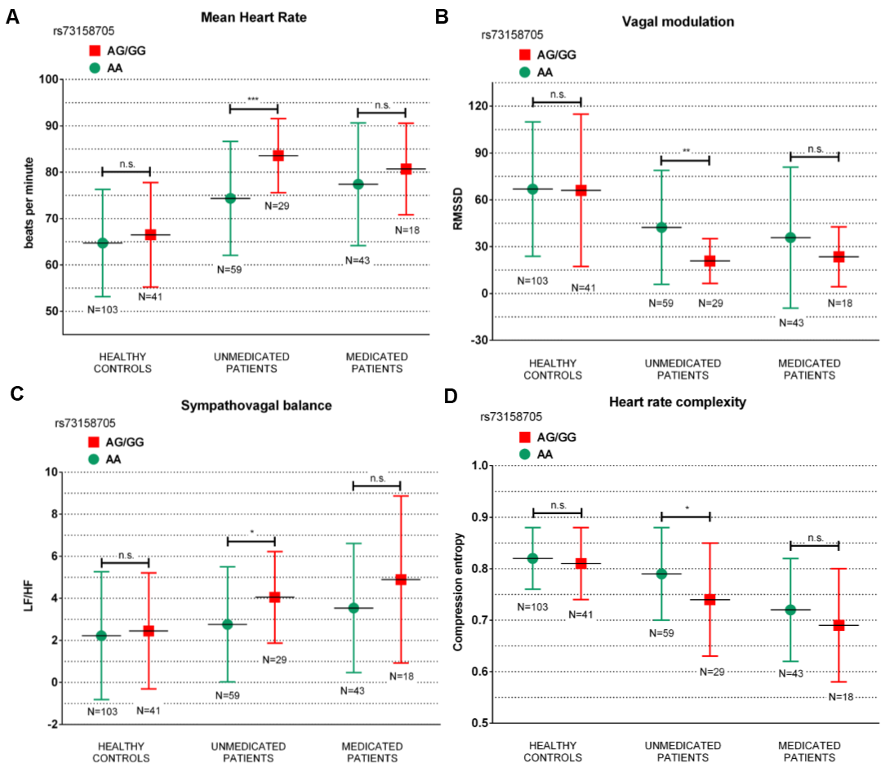

**A, B, C, D.** Error bar charts illustrating differences in mHR (bpm) (A), RMSSD (B), LF/HF (C) and Hc (D) between genotype risk in *CHRM2* rs73158705 in unmedicated patients, medicated patients and healthy controls, * p < 0.05, ** p < 0.01, *** p < 0.001, p-value resulting from ANOVAs. For reasons of clarity only significant differences are displayed.

**Figure 2**

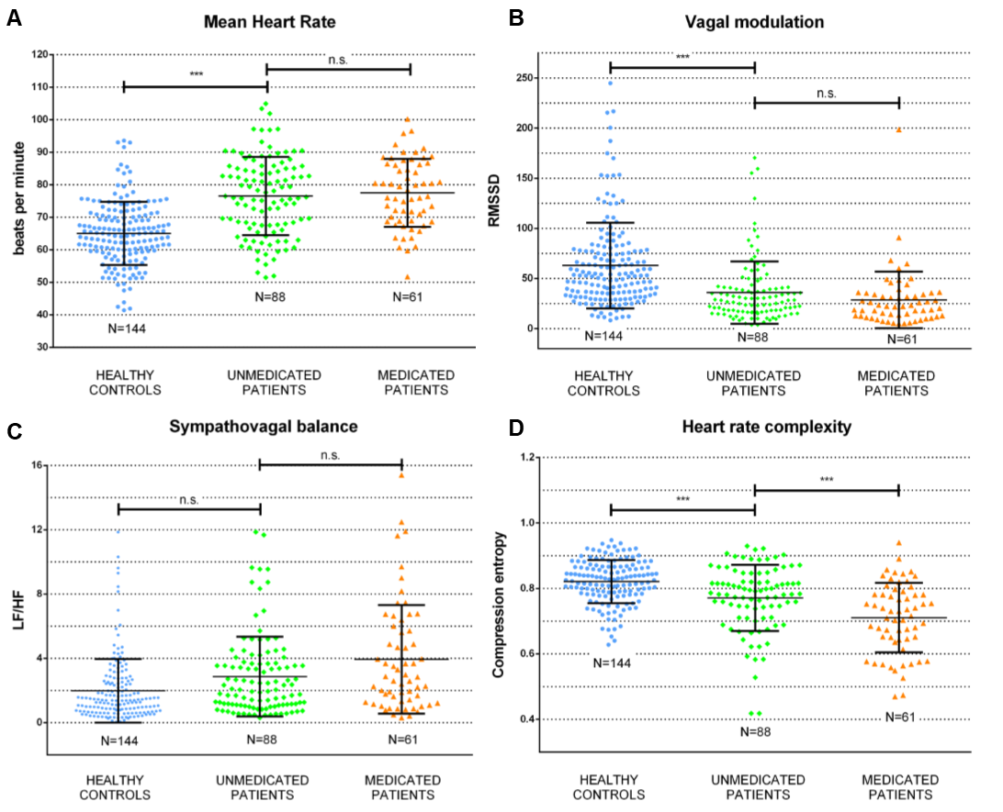

**A, B, C, D.** Scatter dot plot (mean with SD) illustrating differences in mHR (bpm) (A), RMSSD (B), LF/HF (C) and Hc (D) between unmedicated patients and healthy controls and between unmedicated and medicated patients, * p < 0.05, ** p < 0.01, *** p < 0.001, p-value resulting from Bonferroni-adjusted post-hoc t-tests.

**Refisch et al. – Supplemental material**

**Subsequent analysis of another 7 candidate variants at *CHRM2* locus from a former GWAS dataset**

**Methods:**

From a previous study, GWAS data (Illumina's Infinium PsychArray-24 Kit®) were available for 83 unmedicated patients and 96 healthy controls, including 265,000 proven tag SNPs found on the Infinium Core-24 Bead Chip, 245,000 markers from the Infinium Exome-24 BeadChip and 50,000 additional markers associated with the mental disorder. Sociodemographic characteristics of the GWAS sample are shown in ***Supplemental Table 1***. For a total of seven SNPs at the *CHRM2* locus, included on the array, we were able to perform heart rate variability and complexity analyses (***Supplemental Table 2***). Since most known risk alleles are minor allele (He et al. 2017) patients and healthy controls were divided in two genotype subgroups per diagnostic group depending on the presence of a minor allele vs. homozygote major allele genotypes.

**Results:**

Initially we tested the interaction effect *genotype risk* x *diagnostic group* on cardiac autonomic parameters. We found significant interaction effects for all investigated *CHRM2* SNPs (***Supplemental Table 4***).

Next, we tested the main effect for genotype risk on cardiac autonomic parameters separately in unmedicated patients and healthy controls. MANOVAs showed significant main effects of genotype risk in rs10228048 (GG vs. GT/TT) [F(4,78) = 4.66, p = 0.002], rs7800170 (CC vs. AC/AA) [F(4,78) = 3.53, p = 0.011] and rs6963819 (GG vs. AG/AA) [F(4,78) = 3.69, p = 0.008] in the unmedicated patient cohort, but not in healthy controls (***Supplemental Table 2***). Follow-up ANOVAs testing the main effect of *genotype risk* on single parameters separately in each diagnostic group are shown in ***Supplemental Table 2****.*

Lastly, we tested the main effect for single genotypes in the candidate SNPs at the *CHRM2* locus on cardiac autonomic parameters separately in each diagnostic group. We found a significant main effect for single genotypes in rs10228048 (GG vs. GT vs. TT) [F(8, 154) = 3.21, p = 0.002], rs7800170 (CC vs. AC vs. AA) [F(8, 154) = 2.94, p = 0.004] and rs6963819 (GG vs. AG vs. AA) [F(8, 154) = 2.0, p = 0.050] in the unmedicated patient cohort, but not in healthy controls. Follow-up ANOVAS revealed significant main effects for mHR [F(2,80) = 6.69, p = 0.002], RMSSD [F(2,80) = 3.11, p = 0.050] and Hc [F(2,80) = 11.24, p < 0.001] testing single genotypes in *CHMR2* rs10228048 in unmedicated patients. mHR differed significantly comparing single genotypes in rs7800170 [F(2,80) = 7.81, p = 0.001]. None of the Follow-up ANOVAs revealed significant differences comparing single genotypes in rs6963819. Post-hoc-t-tests comparing cardiac autonomic parameters between single genotypes in rs10228048 and rs7800170 are displayed in ***Supplemental*** ***Figure 1 and 2***.

**Discussion:**

We identified three novel candidate variants for reduced vagal modulation in schizophrenia at the *CHRM2* locus. Thus, unmedicated patients with schizophrenia carrying minor alleles in rs10228048 G>T, rs7800170 C>A and rs6963819 G>A revealed significantly reduced heart rate variability and complexity compared to homozygote major allele genotypes. To our knowledge rs10228048, rs7800170 and rs6963819 were not reported in the literature to date. Hence, all three are intronic variants with an undefined functional significance, yet. By identifying three more SNPs, that are associated with reduced heart rate variability and complexity in patients with schizophrenia, these findings support *CHRM2* to be involved in the pathophysiological link between both conditions, schizophrenia and impaired cardiac autonomic function. However, independent patient cohorts are mandatory to validate a possible association of rs10228048 G>T, rs7800170 C>A and rs6963819 G>A with cardiac autonomic features in schizophrenia patients in future studies.

**Supplemental Table 1** Sociodemographic characteristics of the primary sample consisting of 96 healthy controls and 83 unmedicated patients with schizophrenia.

|  |  |  |  |
| --- | --- | --- | --- |
|  | **Diagnostic group** | | p |
| HEALTHY CONTROLS | UNMEDICATED PATIENTS |
| Soziodemographic data | | | |
| N | 96 | 83 |  |
| age (y) | 25.3 ± 3.9 | 33.3 ± 11.0 | <0.001 |
| gender (f/m) | 48/48 | 36/47 | n.s. |
| smoker status (y/n) | 77/19 | 44/39 | 0.040 |
| cig. per day | 1.3 ± 3.3 | 6.9 ± 10.9 | <0.001 |
| cups of coffee a day | 1.0 ± 1.3 | 2.0 ± 1.4 | 0.037 |
| BMI (m/kg2) | 22.7± 3.0 | 22.83 ± 9.5 | n.s. |
| hours of sport per week | 2.8 ± 2.0 | 0.8 ± 1.3 | 0.003 |
| Psychopathology | | | |
| PANSS gen | NA | 42.6 ± 11.7 | n.s. |
| PANSS pos | NA | 21.6 ± 5.5 | n.s. |
| PANSS neg | NA | 23.7 ± 9.0 | 0.02 |
| Cardiac autonomic function | | | |
| mHR | 64.5 ± 1.07 | 76.6 ± 1.11 | <0.001 |
| RMSSD | 73.0 ± 47.8 | 36.3 ± 33.2 | <0.001 |
| LF/HF | 1.6 ± 1.4 | 2.9 ± 2.1 | 0.001 |
| CE | 0.83 ± 0.06 | 0.77 ± 0.1 | <0.001 |

Data expressed as mean (SD). P-values resulting from ANOVAs.

Abbrev.: Minor Allele Frequency (MAF), Mean Heart Rate (mHR), Root Mean Sum of Squared Differences (RMSSD), Heart Rate Low Frequency/High Frequency-ratio (LF/HF), Compression entropy (Hc).

**Supplemental Table 2** Distribution of allele frequencies in *CHRM2* SNPs contained on the array and main effect of genotype subgroups for each SNP on cardiac autonomic parameters

|  |  |  |  |  |  |  |
| --- | --- | --- | --- | --- | --- | --- |
|  | rs324640 G>A | | | | | |
|  | HEALTHY CONTROLS | | | UNMEDICATED PATIENTS | | |
| MAF | A = 0.48 (93/192) | | | A = 0.48 (80/166) | | |
| GG | 0.23 (23/96) | | | 0.23 (19/83) | | |
| AG | 0.52 (49/96) | | | 0.57 (47/83) | | |
| AA | 0.25 (24/96) | | | 0.20 (17/83) | | |
| CAF | GG | AG/AA | Wilks-Lambda* | GG | AG/AA | Wilks-Lambda* |
| N | 23 | 73 | 0.757 | 19 | 64 | 0.082 |
| mHR | 63.2 ± 9.9 | 65.0 ± 9.2 | n.s. | 70.5 ± 9.3 | 78.0 ± 11.7 | n.s. |
| RMSSD | 74.6 ± 50.0 | 70.6 ± 44.6 | n.s. | 38.5 ± 34.8 | 36.9 ± 33.0 | n.s. |
| LF/HF | 1.3 ± 1.1 | 1.7 ± 1.6 | n.s. | 2.4 ± 1.9 | 2.9 ± 2.3 | n.s. |
| Hc | 0.84 ± 0.07 | 0.83 ± 0.06 | n.s. | 0.79 ± 0.07 | 0.77 ± 0.1 | n.s. |
|  | rs10228048 G>T | | | | | |
|  | HEALTHY CONTROLS | | | UNMEDICATED PATIENTS | | |
| MAF | T = 0.26 (49/192) | | | T = 0.25 (41/166) | | |
| GG | 0.57 (55/96) | | | 0.54 (45/83) | | |
| GT | 0.34 (33/96) | | | 0.42 (35/83) | | |
| TT | 0.09 (8/96) | | | 0.04 (3/83) | | |
| CAF | GG | GT/TT | Wilks-Lambda* | GG | GT/TT | Wilks-Lambda* |
| N | 55 | 41 | 0.433 | 45 | 38 | 0.002 |
| mHR | 64.0 ± 9.9 | 65.2 ± 8.8 | n.s. | 72.7 ± 10.9 | 81.0 ± 10.8 | p = 0.001 |
| RMSSD | 70.4 ± 46.3 | 76.5 ± 50.0 | n.s. | 44.2 ± 34.2 | 27.6 ± 27.3 | p = 0.022 |
| LF/HF | 1.4 ± 1.0 | 1.8 ± 1.7 | n.s. | 2.4 ± 1.9 | 3.4 ± 2.4 | p = 0.043 |
| Hc | 0.82 ± 0.06 | 0.83 ± 0.06 | n.s. | 0.81 ± 0.07 | 0.73 ± 0.1 | p <0.001 |
|  | rs7800170 C>A | | | | | |
|  | HEALTHY CONTROLS | | | UNMEDICATED PATIENTS | | |
| MAF | A = 0.48 (92/192) | | | A = 0.46 (77/166) | | |
| CC | 0.29 (28/96) | | | 0.28 (23/83) | | |
| AC | 0.46 (44/96) | | | 0.52 (43/83) | | |
| AA | 0.25 (24/96) | | | 0.20 (17/83) | | |
| CAF | CC | AC/AA | Wilks-Lambda* | CC | AC/AA | Wilks-Lambda* |
| N | 28 | 68 | 0.253 | 23 | 60 | 0.011 |
| mHR | 62.3 ± 9.2 | 65.2 ± 9.4 | n.s. | 71.8 ± 9.5 | 78.3 ± 11.8 | p = 0.020 |
| RMSSD | 88.3 ± 58.1 | 67.9 ± 43.0 | n.s. | 43.7 ± 37.7 | 30.3 ± 24.2 | n.s. |
| LF/HF | 1.5 ± 1.4 | 1.6 ± 1.5 | n.s. | 2.5 ± 2.2 | 2.9 ± 2.2 | n.s. |
| Hc | 0.85 ± 0.05 | 0.82 ± 0.06 | n.s. | 0.79 ± 0.07 | 0.76 ± 0.08 | n.s. |
|  | rs6963819 G>A | | | | | |
|  | HEALTHY CONTROLS | | | UNMEDICATED PATIENTS | | |
| MAF | A = 0.38 (72/192) | | | A = 0.31 (52/166) | | |
| GG | 0.41 (39/96) | | | 0.45 (37/83) | | |
| AG | 0.44 (42/96) | | | 0.48 (40/83) | | |
| AA | 0.15 (15/96) | | | 0.07 (6/83) | | |
| CAF | GG | AG/AA | Wilks-Lambda* | GG | AG/AA | Wilks-Lambda* |
| N | 39 | 57 | 0.010 | 37 | 46 | 0.008 |
| mHR | 64.0 ± 8.6 | 64.8 ± 10.0 | n.s. | 75.5 ± 10.3 | 77.4 ± 12.5 | n.s. |
| RMSSD | 87.8 ± 59.8 | 62.9 ± 34.4 | 0.011 | 43,5 ± 41.0 | 28.1 ± 15.7 | p = 0.034 |
| LF/HF | 1.7 ± 2.0 | 1.5 ± 1.1 | n.s. | 2.6 ± 2.1 | 3.1 ± 2.3 | n.s. |
| Hc | 0.85 ± 0.05 | 0.81 ± 0.06 | 0.001 | 0.79 ± 0.09 | 0.75 ± 0.1 | p = 0.049 |
|  | rs324594 T>C | | | | | |
|  | HEALTHY CONTROLS | | | UNMEDICATED PATIENTS | | |
| MAF | C = 0.26 (50/192) | | | C = 0.25 (41/166) | | |
| TT | 0.55 (53/96) | | | 0.54 (45/83) | | |
| CT | 0.38 (36/96) | | | 0.42 (35/83) | | |
| CC | 0.07 (7/96) | | | 0.04 (3/83) | | |
| CAF | TT | CT/CC | Wilks-Lambda* | TT | CT/CC | Wilks-Lambda* |
| N | 53 | 43 | 0.754 | 45 | 38 | 0.243 |
| mHR | 64.2 ± 9.9 | 64.8 ± 8.9 | n.s. | 76.6 ± 11.2 | 76.4 ± 12.2 | n.s. |
| RMSSD | 78.6 ± 55.0 | 66.1 ± 36.3 | n.s. | 30.5 ± 20.7 | 43.8 ± 42.6 | n.s. |
| LF/HF | 1.5 ± 1.6 | 1.7 ± 1.5 | n.s. | 2.9 ± 2.3 | 2.7 ± 2.0 | n.s. |
| Hc | 0.83 ± 0.06 | 0.82 ± 0.1 | n.s. | 0.76 ± 0.1 | 0.79 ± 0.09 | n.s. |
|  | rs2113545 A>G | | | | | |
|  | HEALTHY CONTROLS | | | UNMEDICATED PATIENTS | | |
| MAF | G = 0.32 (62/192) | | | G = 0.28 (47/166) | | |
| AA | 0.46 (44/96) | | | 0.48 (40/83) | | |
| AG | 0.44 (42/96) | | | 0.47 (39/83) | | |
| GG | 0.10 (10/96) | | | 0.05 (4/83) | | |
| CAF | AA | AG/GG | Wilks-Lambda* | AA | AG/GG | Wilks-Lambda* |
| N | 44 | 52 | 0.489 | 40 | 43 | 0.093 |
| mHR | 63.8 ± 9.9 | 65.1 ± 9.0 | n.s. | 76.3 ± 10.2 | 76.7 ± 12.7 | n.s. |
| RMSSD | 82.6 ± 57.9 | 64.9 ± 35.7 | n.s. | 31.1 ± 20.7 | 41.7 ± 41.0 | n.s. |
| LF/HF | 1.5 ± 1.7 | 1.6 ± 1.4 | n.s. | 3.0 ± 2.4 | 2.6 ± 1.9 | n.s. |
| Hc | 0.84 ± 0.06 | 0.83 ± 0.06 | n.s. | 0.76 ± 0.1 | 0.78 ± 0.1 | n.s. |
|  | rs2350786 A>G | | | | | |
|  | HEALTHY CONTROLS | | | UNMEDICATED PATIENTS | | |
| MAF | G = 0.26 (50/192) | | | G = 0.22 (37/166) | | |
| AA | 0.53 (51/96) | | | 0.59 (49/83) | | |
| AG | 0.42 (40/96) | | | 0.37 (31/83) | | |
| GG | 0.05 (5/96) | | | 0.04 (3/83) | | |
| CAF | AA | AG/GG | Wilks-Lambda* | AA | AG/GG | Wilks-Lambda* |
| N | 51 | 45 | 0.735 | 49 | 34 | 0.098 |
| mHR | 64.0 ± 9.4 | 65.1 ± 9.5 | n.s. | 76.1 ± 10.2 | 77.5 ± 13.2 | n.s. |
| RMSSD | 79.4 ± 54.7 | 65.8 ± 37.8 | n.s. | 33.5 ± 25.2 | 41.1 ± 41.8 | n.s. |
| LF/HF | 1.5 ± 1.6 | 1.7 ± 1.5 | n.s. | 2.9 ± 2.4 | 2.7 ± 1.8 | n.s. |
| Hc | 0.84 ± 0.06 | 0.82 ± 0.06 | n.s. | 0.77 ± 0.1 | 0.79 ± 0.09 | n.s. |

Data expressed as mean (SD). P-values resulting from follow-up ANOVAs.

*\*resulting from MANOVAs comparing the main effect for genotype subgroups on parameters of heart rate variability and complexity*

Abbrev.: Minor Allele Frequency (MAF), Mean Heart Rate (mHR), Root Mean Sum of Squared Distance (RMSSD), Heart Rate Low Frequency/ High Frequency-ratio (LF/HF), Compression entropy (Hc).

**Supplemental Figure 1**

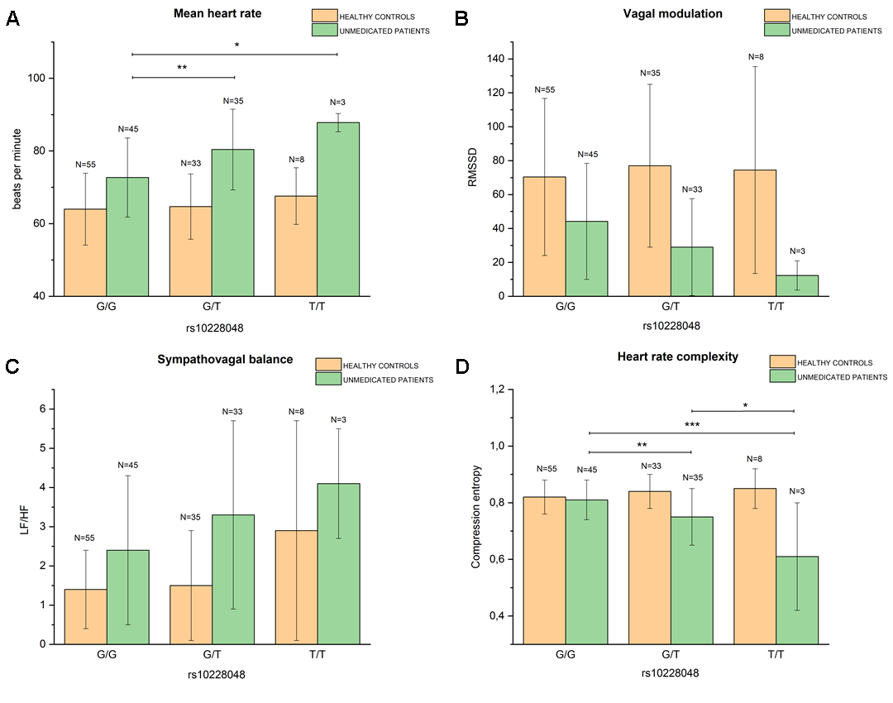

**A, B, C, D.** Bar chart illustrating differences in mHR (bpm) (A), RMSSD (B), LF/HF (C) and Hc (D) between single genotypes in *CHRM2* rs10228048 separately in unmedicated patients, medicated patients and healthy controls, * p < 0.05, ** p < 0.01, *** p < 0.001, p-value resulting from ANOVAs. For reasons of clarity only significant differences are displayed.

**Supplemental Figure 2**

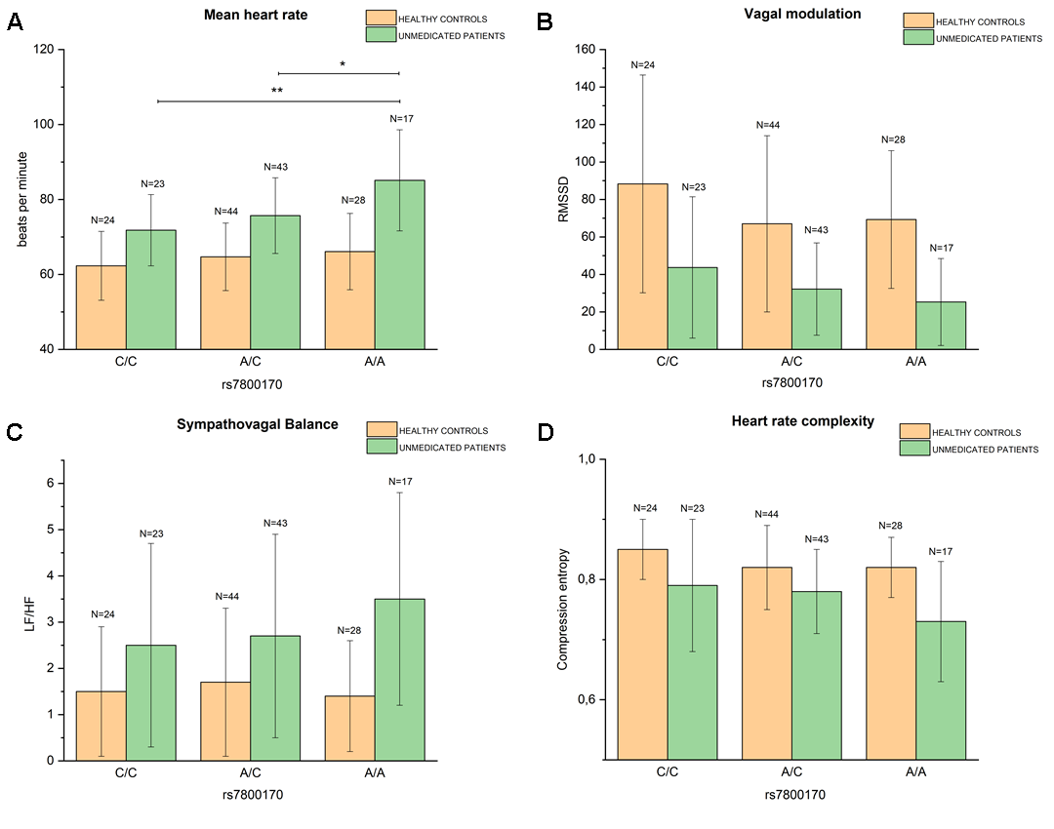

**A, B, C, D.** Bar bar chart illustrating differences in mHR (bpm) (A), RMSSD (B), LF/HF (C) and Hc (D) between genotype risk in *CHRM2* rs7800170 separately in unmedicated patients and healthy controls, * p < 0.05, ** p < 0.01, *** p < 0.001, p-value resulting from ANOVAs. For reasons of clarity only significant differences are displayed

**Supplemental Table 3** Sociodemographic and clinical data of genotype subgroups for rs73158705, rs8191992, rs2350782

|  |  |  |  |  |  |  |  |  |  |  |
| --- | --- | --- | --- | --- | --- | --- | --- | --- | --- | --- |
|  | | **rs73158705** | | | **rs8191992** | | | **rs2350782** | | |
|
| AA | AG/GG | p | TT | AT/AA | p | TT | CT/CC | p |
| N | HC | 103 | 41 | NA | 32 | 112 | NA | 105 | 39 | NA |
| UNMED | 59 | 29 | NA | 17 | 71 | NA | 67 | 21 | NA |
| MED | 43 | 18 | NA | 11 | 50 | NA | 47 | 14 | NA |
| age (y) *mean ± SD* | HC | 30.8 ± 7.4 | 32.2 ± 8.5 | n.s. | 30.6 ± 7.1 | 31.53± 7.9 | n.s. | 31.2 ± 7.5 | 31.0 ± 8.3 | n.s. |
| UNMED | 31.6 ± 10.6 | 33.3 ± 11.3 | n.s. | 32.4 ± 10.0 | 32.1 ± 11.0 | n.s. | 32.2 ± 10.4 | 34.5 ± 11.8 | n.s. |
| MED | 33.4 ± 8.2 | 31.9 ± 12.9 | n.s. | 29.5 ± 10.1 | 33.7 ± 9.6 | n.s. | 34.0 ± 8.1 | 29.5 ± 13.6 | n.s. |
| sex (f/m) | HC | 49/54 | 21/20 | n.s. | 18/14 | 52/60 | n.s. | 49/56 | 21/18 | n.s. |
| UNMED | 29/33 | 12/14 | n.s. | 10/12 | 31/35 | n.s. | 28/33 | 13/14 | n.s. |
| MED | 14/14 | 15/18 | n.s. | 6/7 | 23/25 | n.s. | 20/21 | 9/11 | n.s. |
| smoker status  (y/n) | HC | 19/84 | 11/30 | n.s. | 9/23 | 21/91 | n.s. | 19/86 | 11/28 | n.s. |
| UNMED | 30/29 | 18/11 | n.s. | 11/6 | 37/34 | n.s. | 36/31 | 12/9 | n.s. |
| MED | 24/19 | 11/7 | n.s. | 7/4 | 28/22 | n.s. | 26/21 | 9/5 | n.s. |
| cig. per day *mean ± SD* | HC | 1.3 ± 3.0 | 2.2 ± 4.8 | n.s. | 2.7 ± 5.3 | 1.3 ± 2.9 | n.s. | 1.6 ± 3.6 | 1.6 ± 3.5 | n.s. |
| UNMED | 7.8 ± 10.0 | 8.7 ± 8.8 | n.s. | 9.5 ± 9.3 | 7.7 ± 9.7 | n.s. | 8.0 ± 9.7 | 8.1 ± 9.5 | n.s. |
| MED | 12.0 ± 9.6 | 9.4 ± 6.9 | n.s. | 10.4 ± 7.2 | 11.4 ± 9.3 | n.s. | 10.9 ± 8.3 | 12.3 ± 11.4 | n.s. |
| cups of coffee  a day *mean ± SD* | HC | 1.5 ± 1.5 | 1.9 ± 1.2 | n.s. | 1.6 ± 1.4 | 1.7 ± 1.5 | n.s. | 1.5 ± 1.5 | 2.0 ± 1.2 | n.s. |
| UNMED | 2.4 ± 2.3 | 2.1 ± 1.0 | n.s. | 1.5 ± 0.9 | 2.7 ± 2.1 | n.s. | 2.4 ± 2.1 | 2.0 ± 1.3 | n.s. |
| MED | 3.1 ± 1.5 | 3.1 ± 1.7 | n.s. | 3.1 ± 1.6 | 3.1 ± 1.6 | n.s. | 3.1 ± 1.4 | 3.1 ± 2.3 | n.s. |
| BMI (m/kg2) *mean ± SD* | HC | 22.9 ± 3.1 | 24.1 ± 5.0 | n.s. | 23.4 ± 3.7 | 23.3 ± 3.8 | n.s. | 22.9 ± 3.2 | 24.4 ± 5.1 | n.s. |
| UNMED | 22.4 ± 8.1 | 23.9 ± 4.3 | n.s. | 23.5 ± 4.9 | 22.7 ± 7.5 | n.s. | 22.7 ± 7.8 | 23.5 ± 4.1 | n.s. |
| MED | 21.5 ± 10.2 | 24.6 ± 7.5 | n.s. | 22.3 ± 8.2 | 22.4 ± 9.9 | n.s. | 21.9 ± 9.9 | 24.0 ± 8.1 | n.s. |
| hours of  sport per week *mean ± SD* | HC | 2.1 ± 1.9 | 1.6 ± 1.6 | n.s. | 2.4 ± 2.1 | 1.8 ± 1.7 | n.s. | 2.0 ± 1.8 | 1.6 ± 1.8 | n.s. |
| UNMED | 1.4 ± 1.4 | 1.1 ± 1.5 | n.s. | 0.7 ± 1.6 | 1.5 ± 1.3 | n.s. | 1.4 ± 1.5 | 0.8 ± 1.0 | n.s. |
| MED | 0.7 ± 1.0 | 0.6 ± 1.1 | n.s. | 0.4 ± 0.9 | 0.8 ± 1.0 | n.s. | 0.6 ± 0.9 | 1.1 ± 1.2 | n.s. |
| PANSS gen *mean ± SD* | HC | NA | NA | NA | NA | NA | NA | NA | NA | NA |
| UNMED | 40.1 ± 10.5 | 48.3 ± 13.3 | 0.012 | 46.1 ± 9.3 | 41.8 ± 12.2 | n.s. | 40.3 ± 10.5 | 49.9 ± 13.7 | 0.009 |
| MED | 44.5 ± 7.8 | 40.2 ± 14.3 | n.s. | 42.8 ± 11.5 | 44.2 ± 12.8 | n.s. | 46.2 ± 7.8 | 39.1 ± 10.5 | n.s. |
| PANSS pos *mean ± SD* | HC | NA | NA | n.s. | NA | NA | n.s. | NA | NA | n.s. |
| UNMED | 21.8 ± 5.7 | 22.1 ± 6.9 | n.s. | 23.2 ± 6.4 | 21.6 ± 6.0 | n.s. | 21.5 ± 6.5 | 22.9 ± 7.1 | n.s. |
| MED | 22.3 ± 6.5 | 19.5 ± 7.8 | n.s. | 20.0 ± 8.3 | 21.8 ± 7.1 | n.s. | 22.3 ± 5.7 | 18.3 ± 7.7 | n.s. |
| PANSS neg *mean ± SD* | HC | NA | NA | n.s. | NA | NA | n.s. | NA | NA | n.s. |
| UNMED | 20.3 ± 8.5 | 25.1 ± 8.1 | 0.044 | 24.8 ± 8.0 | 21.6 ± 8.7 | n.s. | 20.9 ± 8.6 | 24.4 ± 8.2 | n.s. |
| MED | 29.4 ± 6.6 | 24.5 ± 12.5 | n.s. | 27.8 ± 6.5 | 28.5 ± 11.0 | n.s. | 28.4 ± 6.5 | 26.8 ± 9.5 | n.s. |

Data expressed as mean (SD). P-values resulting from ANOVAs.

Abbrev.: BMI: Body mass index; PANSS: Positive and Negative Syndrome Scale (Kay et al. 1987); HC: Healthy controls; UNMED: Unmedicated patients with schizophrenia; MED: Medicated patients with schizophrenia.

**Supplemental Table 4** Interaction effect *genotype risk x diagnostic group* on parameters of heart rate variability and complexity for all selected *CHRM2* SNPs

|  |  |  |  |  |
| --- | --- | --- | --- | --- |
| interaction effect | mHR | RMSSD | LF/HF | Hc |
| diagnostic group1 x rs7315870 | F(5,287) = 20.22; p < 0.001 | F(5,287) = 11.17; p < 0.001 | F(5,287) = 4.25; p = 0.001 | F(5,287) = 16.23; p < 0.001 |
| diagnostic group1 x rs8191992 | F(5,287) = 22.03; p < 0.001 | F(5,287) = 11.57; p < 0.001 | F(5,287) = 5.22; p < 0.001 | F(5,287) = 15.44; p < 0.001 |
| diagnostic group1 x rs2350782 | F(5,287) = 18.18; p < 0.001 | F(5,287) = 10.93; p < 0.001 | F(5,287) = 3.04; p = 0.011 | F(5,287) = 15.90; p < 0.001 |
| interaction effect | mHR | RMSSD | LF/HF | Hc |
| diagnostic group2 x rs324640 | F(3,175) = 21.44; p < 0.001 | F(3,175) = 10.42; p < 0.001 | F(3,175) = 6.67; p < 0.001 | F(3,175) = 5.98; p = 0.001 |
| diagnostic group2 x rs10228048 | F(3,175) = 25.67; p < 0.001 | F(3,175) = 12.76; p < 0.001 | F(3,175) = 9.13; p < 0.001 | F(3,175) = 14.30; p < 0.001 |
| diagnostic group2 x rs7800170 | F(3,175) = 22.94; p < 0.001 | F(3,175) = 13.13; p < 0.001 | F(3,175) = 7.00; p < 0.001 | F(3,175) = 7.46; p < 0.001 |
| diagnostic group2 x rs6963819 | F(3,175) = 19.68; p < 0.001 | F(3,175) = 15.90; p < 0.001 | F(3,175) = 7.40; p < 0.001 | F(3,175) = 10.69; p < 0.001 |
| diagnostic group2 x rs324594 | F(3,175) = 19.38; p < 0.001 | F(3,175) = 12.95; p < 0.001 | F(3,175) = 6.90; p < 0.001 | F(3,175) = 7.29; p < 0.001 |
| diagnostic group2 x rs2113545 | F(3,175) = 19.96; p < 0.001 | F(3,175) = 13.54; p < 0.001 | F(3,175) = 7.05; p < 0.001 | F(3,175) = 7.21; p < 0.001 |
| diagnostic group2 x rs2350786 | F(3,175) = 20.39; p < 0.001 | F(3,175) = 12.52; p < 0.001 | F(3,175) = 6.89; p < 0.001 | F(3,175) = 6.93; p < 0.001 |

*1 144 healthy controls vs. 88 unmedicated patients with schizophrenia vs. 66 medicated patients with schizophrenia*

*2 96 healthy controls vs. 83 unmedicated patients with schizophrenia*

**Supplemental Figure 3**

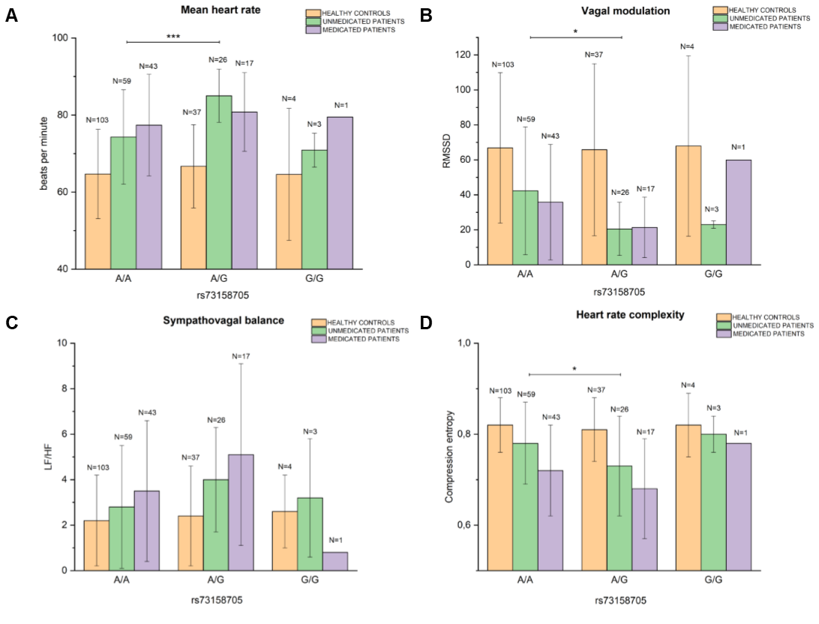

**A, B, C, D.** Bar chart illustrating differences in mHR (bpm) (A), RMSSD (B), LF/HF (C) and Hc (D) between single genotypes in *CHRM2* rs73158705 in unmedicated patients, medicated patients and healthy controls, * p < 0.05, ** p < 0.01, *** p < 0.001, p-value resulting from ANOVAs. For reasons of clarity only significant differences are displayed

.

**References**

Agelink MW, Majewski T, Wurthmann C, Lukas K, Ullrich H, Linka T, Klieser E. 2001. Effects of newer atypical antipsychotics on autonomic neurocardiac function: a comparison between amisulpride, olanzapine, sertindole, and clozapine. Journal of clinical psychopharmacology. 21(1):8-13. eng.

Bär. 2015. Cardiac Autonomic Dysfunction in Patients with Schizophrenia and Their Healthy Relatives - A Small Review. Frontiers in neurology. 6:139. eng.

Bär, Berger S, Metzner M, Boettger MK, Schulz S, Ramachandraiah CT, Terhaar J, Voss A, Yeragani VK, Sauer H. 2010. Autonomic dysfunction in unaffected first-degree relatives of patients suffering from schizophrenia. Schizophrenia bulletin. 36(5):1050-1058.

Bär, Letzsch A, Jochum T, Wagner G, Greiner W, Sauer H. 2005. Loss of efferent vagal activity in acute schizophrenia. Journal of psychiatric research. 39(5):519-527. eng.

Bär KJ, Boettger MK, Koschke M, Schulz S, Chokka P, Yeragani VK, Voss A. 2007. Non-linear complexity measures of heart rate variability in acute schizophrenia. Clinical neurophysiology : official journal of the International Federation of Clinical Neurophysiology. 118(9):2009-2015. eng.

Baumert M, Baier V, Haueisen J, Wessel N, Meyerfeldt U, Schirdewan A, Voss A. 2004. Forecasting of life threatening arrhythmias using the compression entropy of heart rate. Methods of information in medicine. 43(2):202-206. eng.

Billman GE. 2013. The LF/HF ratio does not accurately measure cardiac sympatho-vagal balance. Frontiers in physiology. 4:26-26. eng.

Brannan SK, Sawchak S, Miller AC, Lieberman JA, Paul SM, Breier A. 2021. Muscarinic Cholinergic Receptor Agonist and Peripheral Antagonist for Schizophrenia. New England Journal of Medicine. 384(8):717-726.

Brodde OE, Michel MC. 1999. Adrenergic and muscarinic receptors in the human heart. Pharmacological reviews. 51(4):651-690. eng.

Burghardt K, Grove T, Ellingrod V. 2014. Endothelial nitric oxide synthetase genetic variants, metabolic syndrome and endothelial function in schizophrenia. Journal of psychopharmacology (Oxford, England). 28(4):349-356. eng.

Chen X, Lee G, Maher BS, Fanous AH, Chen J, Zhao Z, Guo A, van den Oord E, Sullivan PF, Shi J et al. 2011. GWA study data mining and independent replication identify cardiomyopathy-associated 5 (CMYA5) as a risk gene for schizophrenia. Molecular psychiatry. 16(11):1117-1129.

Clamor A, Lincoln TM, Thayer JF, Koenig J. 2016. Resting vagal activity in schizophrenia: meta-analysis of heart rate variability as a potential endophenotype. The British journal of psychiatry : the journal of mental science. 208(1):9-16. eng.

De Hert M, Detraux J, Vancampfort D. 2018. The intriguing relationship between coronary heart disease and mental disorders. Dialogues Clin Neurosci. 20(1):31-40. eng.

De Hert M, Detraux J, Vancampfort D. 2018. The intriguing relationship between coronary heart disease and mental disorders. Dialogues Clin Neurosci. 20(1):31-40. eng.

den Hoed M, Eijgelsheim M, Esko T, Brundel BJ, Peal DS, Evans DM, Nolte IM, Segrè AV, Holm H, Handsaker RE et al. 2013. Identification of heart rate-associated loci and their effects on cardiac conduction and rhythm disorders. Nature genetics. 45(6):621-631. eng.

Dhein S, van Koppen CJ, Brodde OE. 2001. Muscarinic receptors in the mammalian heart. Pharmacological research. 44(3):161-182. eng.

Diaz A, Bourassa MG, Guertin MC, Tardif JC. 2005. Long-term prognostic value of resting heart rate in patients with suspected or proven coronary artery disease. Eur Heart J. 26(10):967-974. eng.

Eppinga RN, Hagemeijer Y, Burgess S, Hinds DA, Stefansson K, Gudbjartsson DF, van Veldhuisen DJ, Munroe PB, Verweij N, van der Harst P. 2016. Identification of genomic loci associated with resting heart rate and shared genetic predictors with all-cause mortality. Nature genetics. 48(12):1557-1563. eng.

Fisher JT, Vincent SG, Gomeza J, Yamada M, Wess J. 2004. Loss of vagally mediated bradycardia and bronchoconstriction in mice lacking M2 or M3 muscarinic acetylcholine receptors. Faseb j. 18(6):711-713. eng.

Furlan R, Porta A, Costa F, Tank J, Baker L, Schiavi R, Robertson D, Malliani A, Mosqueda-Garcia R. 2000. Oscillatory patterns in sympathetic neural discharge and cardiovascular variables during orthostatic stimulus. Circulation. 101(8):886-892. eng.

Ghoshal A, Rook JM, Dickerson JW, Roop GN, Morrison RD, Jalan-Sakrikar N, Lamsal A, Noetzel MJ, Poslusney MS, Wood MR et al. 2016. Potentiation of M1 Muscarinic Receptor Reverses Plasticity Deficits and Negative and Cognitive Symptoms in a Schizophrenia Mouse Model. Neuropsychopharmacology. 41(2):598-610. eng.

Greenland P, Daviglus ML, Dyer AR, Liu K, Huang CF, Goldberger JJ, Stamler J. 1999. Resting heart rate is a risk factor for cardiovascular and noncardiovascular mortality: the Chicago Heart Association Detection Project in Industry. Am J Epidemiol. 149(9):853-862. eng.

Hansen T, Ingason A, Djurovic S, Melle I, Fenger M, Gustafsson O, Jakobsen KD, Rasmussen HB, Tosato S, Rietschel M et al. 2011. At-risk variant in TCF7L2 for type II diabetes increases risk of schizophrenia. Biological psychiatry. 70(1):59-63. eng.

Hautala AJ, Rankinen T, Kiviniemi AM, Mäkikallio TH, Huikuri HV, Bouchard C, Tulppo MP. 2006. Heart rate recovery after maximal exercise is associated with acetylcholine receptor M2 (CHRM2) gene polymorphism. American journal of physiology Heart and circulatory physiology. 291(1):H459-466. eng.

Hautala AJ, Tulppo MP, Kiviniemi AM, Rankinen T, Bouchard C, Mäkikallio TH, Huikuri HV. 2009. Acetylcholine receptor M2 gene variants, heart rate recovery, and risk of cardiac death after an acute myocardial infarction. Annals of medicine. 41(3):197-207. eng.

He P, Lei X, Yuan D, Zhu Z, Huang S. 2017. Accumulation of minor alleles and risk prediction in schizophrenia. Scientific Reports. 7(1):11661.

Hjorthøj C, Stürup AE, McGrath JJ, Nordentoft M. 2017. Years of potential life lost and life expectancy in schizophrenia: a systematic review and meta-analysis. The Lancet Psychiatry. 4(4):295-301.

Jauregui OI, Costanzo EY, de Achaval D, Villarreal MF, Chu E, Mora MC, Vigo DE, Castro MN, Leiguarda RC, Bar KJ et al. 2011. Autonomic nervous system activation during social cognition tasks in patients with schizophrenia and their unaffected relatives. Cognitive and behavioral neurology : official journal of the Society for Behavioral and Cognitive Neurology. 24(4):194-203. eng.

Jensen MT, Marott JL, Lange P, Vestbo J, Schnohr P, Nielsen OW, Jensen JS, Jensen GB. 2013. Resting heart rate is a predictor of mortality in COPD. Eur Respir J. 42(2):341-349. eng.

Jiménez-Morales S, Jiménez-Ruíz JL, Del Río-Navarro BE, Navarro-Olivos E, Escamilla-Guerrero G, Savan R, Dean M, Orozco L. 2014. CHRM2 but not CHRM1 or CHRM3 polymorphisms are associated with asthma susceptibility in Mexican patients. Molecular biology reports. 41(4):2109-2117. eng.

Karczewski KJ, Francioli LC, Tiao G, Cummings BB, Alföldi J, Wang Q, Collins RL, Laricchia KM, Ganna A, Birnbaum DP et al. 2020. The mutational constraint spectrum quantified from variation in 141,456 humans. Nature. 581(7809):434-443.

Katerina Z, Andrew K, Filomena M, Xu-Feng H. 2004. Investigation of M1/M4 Muscarinic Receptors in the Anterior Cingulate Cortex in Schizophrenia, Bipolar Disorder, and Major Depression Disorder. Neuropsychopharmacology. 29(3):619-625.

Kay SR, Fiszbein A, Opler LA. 1987. The positive and negative syndrome scale (PANSS) for schizophrenia. Schizophrenia bulletin. 13(2):261-276. eng.

Laursen TM, Nordentoft M, Mortensen PB. 2014. Excess early mortality in schizophrenia. Annual review of clinical psychology. 10:425-448. eng.

Lippman N, Stein KM, Lerman BB. 1994. Comparison of methods for removal of ectopy in measurement of heart rate variability. The American journal of physiology. 267(1 Pt 2):H411-418. eng.

Liu Y, Huang Y, Zhou J, Li G, Chen J, Xiang Z, Wu F, Wu K. 2021. Altered Heart Rate Variability in Patients With Schizophrenia During an Autonomic Nervous Test. Frontiers in psychiatry. 12:626991. eng.

Machiela MJ, Chanock SJ. 2015. LDlink: a web-based application for exploring population-specific haplotype structure and linking correlated alleles of possible functional variants. Bioinformatics. 31(21):3555-3557. eng.

Mäki-Marttunen T, Lines GT, Edwards AG, Tveito A, Dale AM, Einevoll GT, Andreassen OA. 2017. Pleiotropic effects of schizophrenia-associated genetic variants in neuron firing and cardiac pacemaking revealed by computational modeling. Translational Psychiatry. 7(11):5.

Malik MC, J.; Bigger J. . 1996. Heart Rate Variability. Circulation. 93(5):1043-1065.

Miyauchi M, Kishida I, Suda A, Shiraishi Y, Hattori S, Fujibayashi M, Taguri M, Ishii C, Ishii N, Moritani T et al. 2016. Association of the Cholinergic Muscarinic M2 Receptor with Autonomic Nervous System Activity in Patients with Schizophrenia on High-Dose Antipsychotics. Neuropsychobiology. 74(1):60-67. eng.

Montano N, Porta A, Cogliati C, Costantino G, Tobaldini E, Casali KR, Iellamo F. 2009. Heart rate variability explored in the frequency domain: a tool to investigate the link between heart and behavior. Neuroscience and biobehavioral reviews. 33(2):71-80. eng.

Mothi SS, Tandon N, Padmanabhan J, Mathew IT, Clementz B, Tamminga C, Pearlson G, Sweeney J, Keshavan MS. 2015. Increased cardiometabolic dysfunction in first-degree relatives of patients with psychotic disorders. Schizophr Res. 165(1):103-107. eng.

Olfson M, Gerhard T, Huang C, Crystal S, Stroup TS. 2015. Premature Mortality Among Adults With Schizophrenia in the United States. JAMA psychiatry. 72(12):1172-1181. eng.

Pagani M, Lucini D, Porta A. 2012. Sympathovagal balance from heart rate variability: time for a second round? Experimental Physiology. 97(10):1141-1142.

Palatini P. 2013. Heart rate and the cardiometabolic risk. Current hypertension reports. 15(3):253-259. eng.

Pardiñas AF, Holmans P, Pocklington AJ, Escott-Price V, Ripke S, Carrera N, Legge SE, Bishop S, Cameron D, Hamshere ML et al. 2018. Common schizophrenia alleles are enriched in mutation-intolerant genes and in regions under strong background selection. Nature genetics.

Raedler TJ, Bymaster FP, Tandon R, Copolov D, Dean B. 2007. Towards a muscarinic hypothesis of schizophrenia. Molecular psychiatry. 12(3):232-246.

Rajendra Acharya U, Paul Joseph K, Kannathal N, Lim CM, Suri JS. 2006. Heart rate variability: a review. Med Biol Eng Comput. 44(12):1031-1051. eng.

Refisch A, Chung HY, Komatsuzaki S, Schumann A, Mühleisen TW, Nöthen MM, Hübner CA, Bär KJ. 2021. A common variation in HCN1 is associated with heart rate variability in schizophrenia. Schizophr Res. 229:73-79. eng.

Reyes del Paso GA, Langewitz W, Mulder LJ, van Roon A, Duschek S. 2013. The utility of low frequency heart rate variability as an index of sympathetic cardiac tone: a review with emphasis on a reanalysis of previous studies. Psychophysiology. 50(5):477-487. eng.

Riese H, Muñoz LM, Hartman CA, Ding X, Su S, Oldehinkel AJ, van Roon AM, van der Most PJ, Lefrandt J, Gansevoort RT et al. 2014. Identifying genetic variants for heart rate variability in the acetylcholine pathway. PloS one. 9(11):e112476. eng.

Ringen PA, Engh JA, Birkenaes AB, Dieset I, Andreassen OA. 2014. Increased mortality in schizophrenia due to cardiovascular disease - a non-systematic review of epidemiology, possible causes, and interventions. Frontiers in psychiatry. 5:137. eng.

Ripke S, Neale BM, Corvin A, Walters JTR, Farh K-H, Holmans PA, Lee P, Bulik-Sullivan B, Collier DA, Huang H et al. 2014. Biological insights from 108 schizophrenia-associated genetic loci. Nature. 511(7510):421-427.

Saternos HC, Almarghalani DA, Gibson HM, Meqdad MA, Antypas RB, Lingireddy A, AbouAlaiwi WA. 2018. Distribution and function of the muscarinic receptor subtypes in the cardiovascular system. Physiological genomics. 50(1):1-9. eng.

Scarr E, Gibbons AS, Neo J, Udawela M, Dean B. 2013. Cholinergic connectivity: it's implications for psychiatric disorders. Frontiers in cellular neuroscience. 7:55. eng.

So HC, Chau KL, Ao FK, Mo CH, Sham PC. 2019. Exploring shared genetic bases and causal relationships of schizophrenia and bipolar disorder with 28 cardiovascular and metabolic traits. Psychological medicine. 49(8):1286-1298. eng.

Solé X, Guinó E, Valls J, Iniesta R, Moreno V. 2006. SNPStats: a web tool for the analysis of association studies. Bioinformatics. 22(15):1928-1929. eng.

Stroup TS, Gray N. 2018. Management of common adverse effects of antipsychotic medications. World psychiatry : official journal of the World Psychiatric Association (WPA). 17(3):341-356. eng.

Stuckey MI, Kiviniemi A, Gill DP, Shoemaker JK, Petrella RJ. 2015. Associations between heart rate variability, metabolic syndrome risk factors, and insulin resistance. Applied physiology, nutrition, and metabolism = Physiologie appliquee, nutrition et metabolisme. 40(7):734-740. eng.

Tani M, Akashi N, Hori K, Konishi K, Kitajima Y, Tomioka H, Inamoto A, Hirata A, Tomita A, Koganemaru T et al. 2015. Anticholinergic Activity and Schizophrenia. Neuro-degenerative diseases. 15(3):168-174. eng.

Thayer JF, Ahs F, Fredrikson M, Sollers JJ, 3rd, Wager TD. 2012. A meta-analysis of heart rate variability and neuroimaging studies: implications for heart rate variability as a marker of stress and health. Neuroscience and biobehavioral reviews. 36(2):747-756. eng.

Thayer JF, Yamamoto SS, Brosschot JF. 2010. The relationship of autonomic imbalance, heart rate variability and cardiovascular disease risk factors. International journal of cardiology. 141(2):122-131. eng.

Vancampfort D, Wampers M, Mitchell AJ, Correll CU, De Herdt A, Probst M, De Hert M. 2013. A meta-analysis of cardio-metabolic abnormalities in drug naïve, first-episode and multi-episode patients with schizophrenia versus general population controls. World psychiatry : official journal of the World Psychiatric Association (WPA). 12(3):240-250. eng.